Chronos Business Object Respository
CWT Backend administration

the Chronos Business Object Repository

Introduction
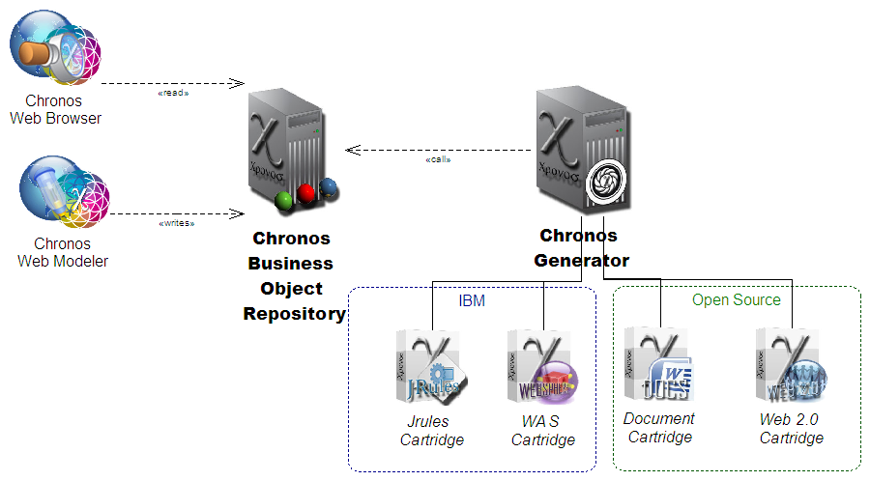Illustration 1: Chronos Business Object Repository in the context
The Chronos BusinessObject Repository is the backend application for Chronos Web Tools and other front end programs. It hosts a repository of Chronos Objects and sgffers the services to access to them.
The BOR is supposed to remain an invisible presence for end users, but is useful for administrators.

Starting the BOR

Start URL in a supported browser ( firefox minimum version 3 or google Chrome).

https://SERVERNAME /cwm/application
(directory where is main.php )

An overview about available functionality is then shown.

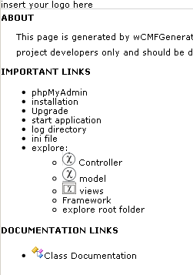

Click link [start application] to start the administration tool, you will get a login panel first.

( you also could have started main.php directly from URL )

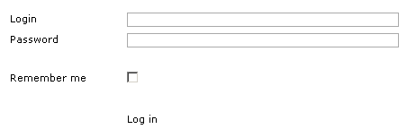

Fill in user name and password and click link [Log in].

(if you don’t want to type in your login information next time you login, mark ‘Remember me’ selected before)

You will see then something like following screenshot, in this case on model level.

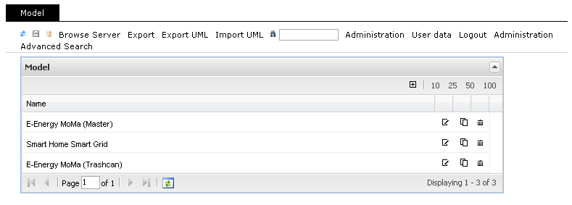

You entered now the administration tool.

Functionalities of the Chronos Business Object Repository
With the BOR you are able to

- read and edit modelling objects and its hierarchical structure
- show content tree

- administer users and their roles
- create and edit configuration files
- change your own user data like password

- search modelling objects, users and roles

read and edit modelling objects and its hierarchical structure,
show content tree

Read, create and edit modelling objects and its hierarchical structure

You see at first a list of models, double-click on one model opens model properties and shows all connections on the right side of the screen.

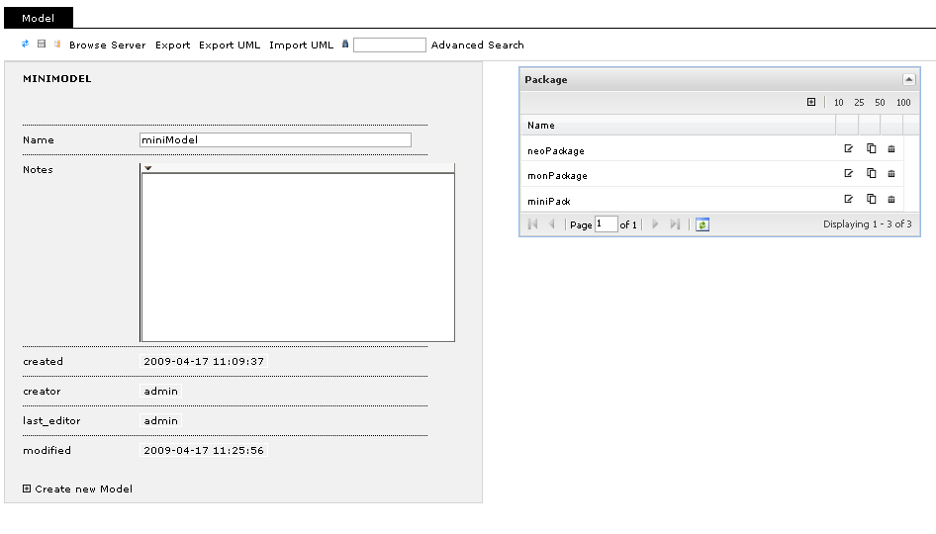
With the same procedure double-click on one connected object on the right you open this one on left side and its connected objects are now shown on the right.

Note, all connected objects are shown, higher level too, so you can easily navigate in tree all directions.

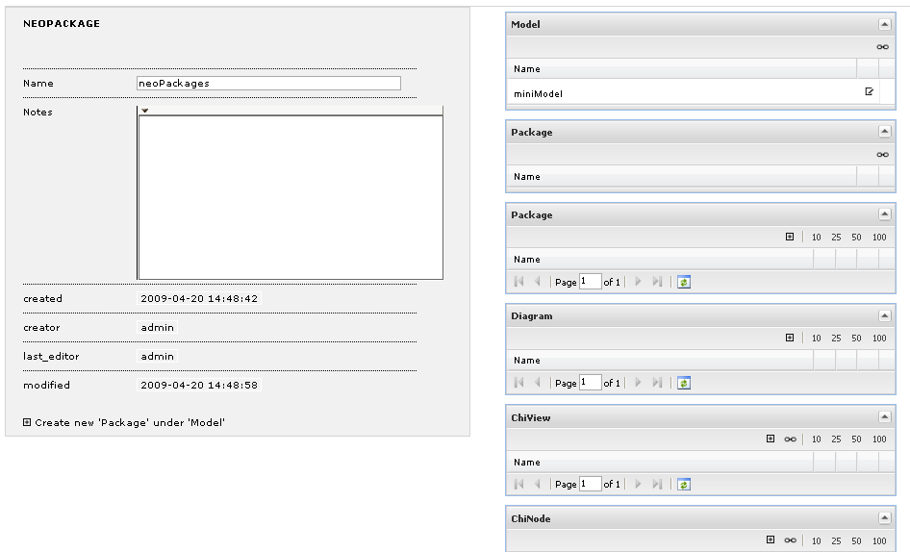

To create a new object you click the [+] Create new ‘Objectname’ link and then opens a new Panel where you can type in the necessary Values.
To save the changes click the save symbol on the top left corner.

As you can see there is one more Object created.
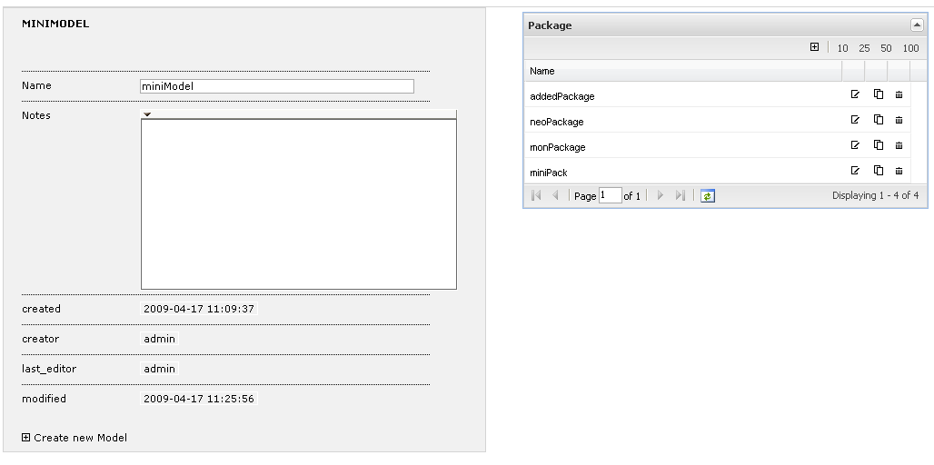

Editing of existing Objects is working analogue.

Show content tree

Click link [Administration].

Anywhere in this area click link [Content Tree] from top left corner and there is opening a separate window to browse the hierarchy of modelling objects.

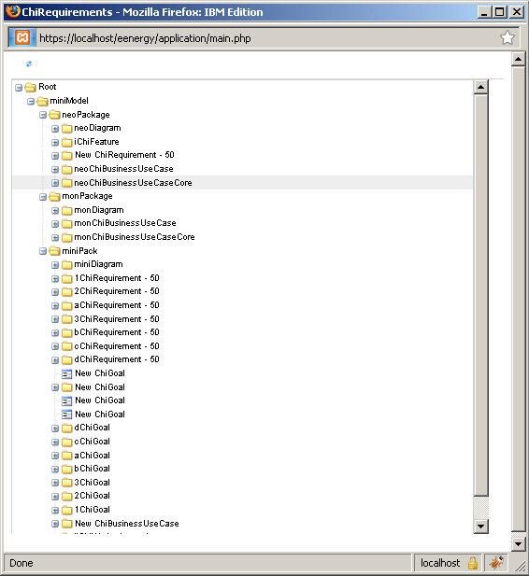

Click link [CMS] on the top right corner to go back to the model objects overview.

administer users and their roles, create and edit configuration files, change your own user data like password

How to arrange configuration files roles and users

You can get a detailed description on sourceforge wcmf documentation about configuration. See http://wcmf.sourceforge.net/docs/html/configuration.html#configuration .

You are able to create and change configuration files using administration tool instead of editing on file system. See ‘create a configuration file’ and ‘edit a configuration file’.

Example configuration files:

config.ini is the default and main configuration file. Here you save the mapping between roles and configuration files in section [roleconfig].
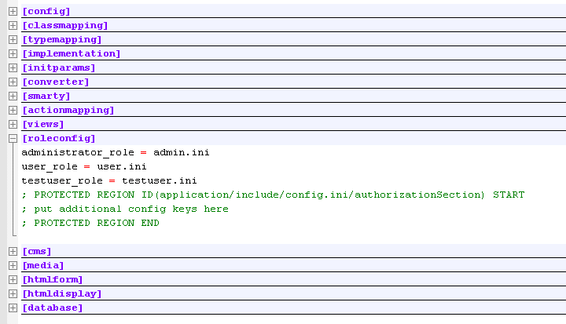
same in administration tool looks like this
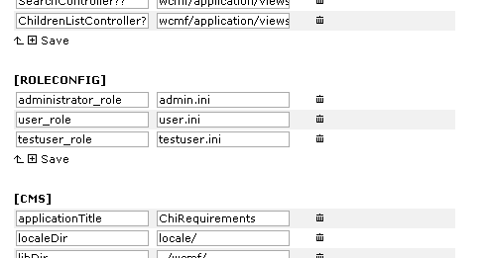

user.ini is the special configuration file for users which are able to do everything on application except displaying the historylist of all objects. In this ini is the only entry the exception of rights for the role and users in section [authorization].
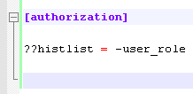
same in administration tool would be
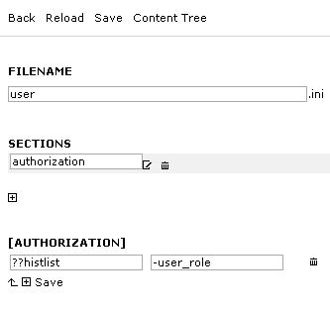

admin.ini is the special configuration file for administrators meens users who are able to do everything on application, so you don’t really need this ini or any entry in this case and would have the same behaviour. But to hold on definition and to show a consistent and readable configuration you could create it with following shown entry.
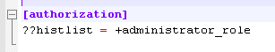
in administration tool looks like this
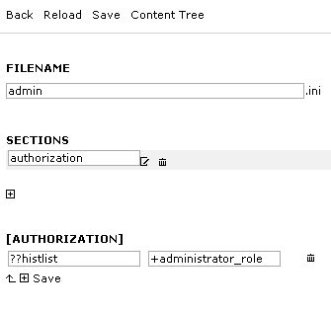

You are able to control all actions in section [actionmapping].

get an overview about existing users and their roles

Click the link [Administration] on top right corner and you will see a list of users, roles and configuration files. The category Backup is also shown there.
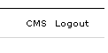
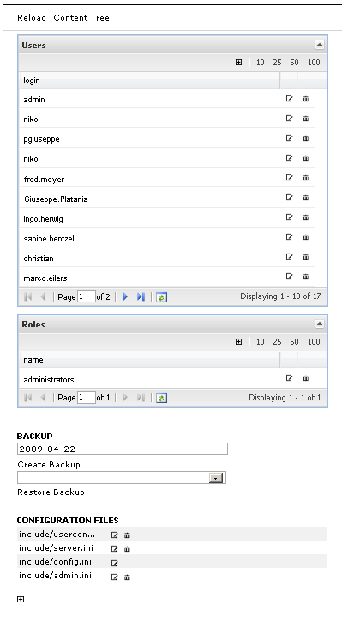

Click link [CMS] on the top right corner to go back to the model objects overview.

Change the properties of an existing user

To edit a user click beside the user name or doubleclick the name directly. Then there is opening a Panel showing all values corresponding to the user and to change all of these values.

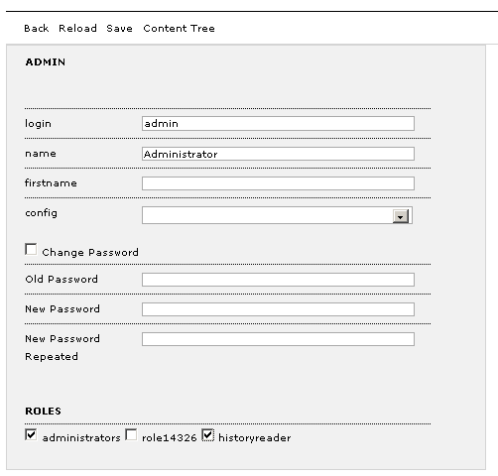

To change the password mark field ‘Change Password’ selected and type the old one (text in clear) in the ‘Old Password’ field and the new one in fields ‘New Password’ and ‘New Password Repeated’.

Click link [save] to confirm the change.

(Note, there is no way to change the password without typing in clear even as an administrator. To reset the password just delete the user and create a new one with a new password.)

Add a new user

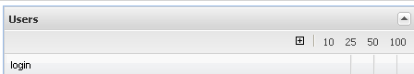

Click [+] to open a new user panel where you can type in the required values.

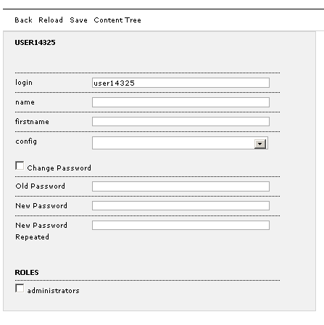
To create a password you have to select Change Password and leaf the Old Password field empty.

Click link [Save] to save the new user.

Delete a user

There is a trash symbol beside the username in the user names list. Click on it to delete the entry, you will receive a confirmation message to confirm deleting.

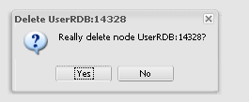

Change the properties of an existing role

Add a new role

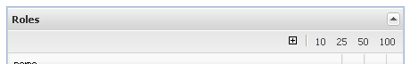

To add a new role click the symbol. Then you will see a new role panel where you can type in the name and check users who have this role applied. To save your changes click link [Save].

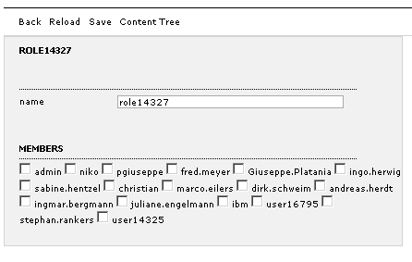

Delete a role

To delete a role click the trash symbol beside the role name in the role list.
You will get an confirmation message to confirm the deletion.

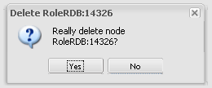

Create an configuration file

See topic ‘get an overview about existing users’, there are listed the configuration files too.

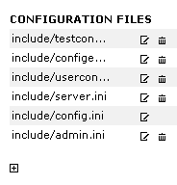
To crate a new configuration file click on the [+] symbol on the bottom.

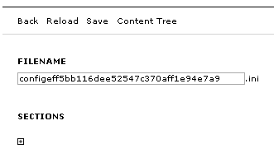
Create a section clicking on symbol [+] and type in the filename and the sections name.

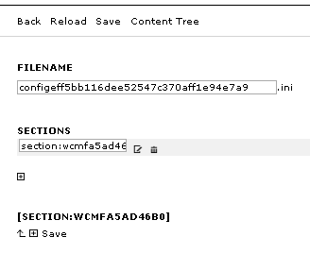

Click link [Save] to save changes. You will see the non editable sections name on the bottom also changes.

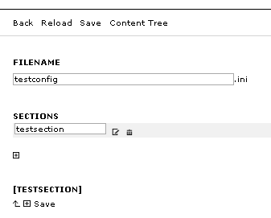

Now you are able to create an option in section by clicking [+].

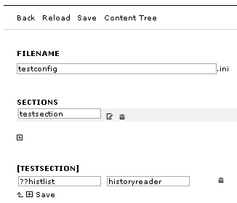

This entry will be written to the config file in the format ??histlist = historyreader. Confirm your change by clicking link [Save].

Delete a configuration file

See topic ‘get an overview about existing users’, there are listed the configuration files too.

To delete one of these entries click on the trash symbol beside the entry.

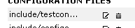

Your will get a confirmation message to confirm the deletion.

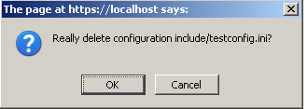

You can not delete the default configuration file because just one default file is needed every time.

Edit a configuration file

See topic ‘get an overview about existing users’, there are listed the configuration files too. To edit a configuration file click on its name or on the edit symbol .

Then you will see all given properties of configuration file.

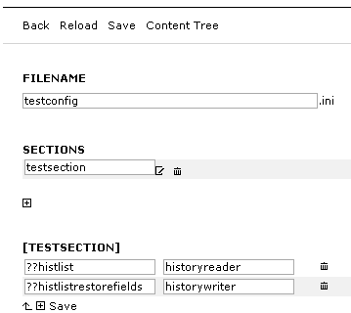

Edit your own user data like password

Click [User data] on the top right corner to open the password change panel. Type in the old and new password in the fields and click link [Save] to confirm.

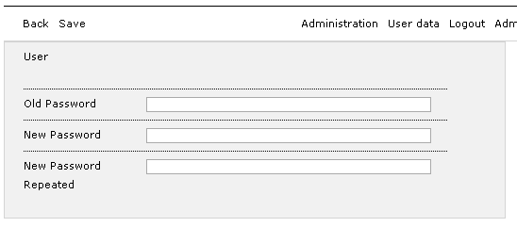

search modelling objects, users and roles

Simple search:

On the top you see some action links and among these a field to start searching. Type in the search key, for instance ‘user’, you are looking for and click the spyglass symbol to start action.

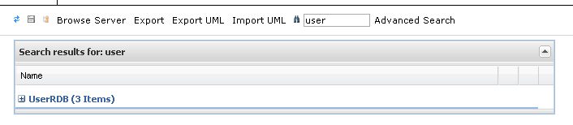

Expanding section by clicking [+] symbol all the result entries are shown.

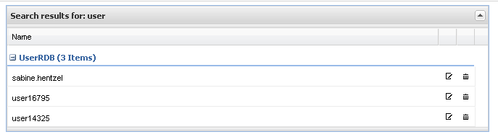

Advanced search

To perform an advanced Search just click action [Advanced Search] to open the separate advanced search window.

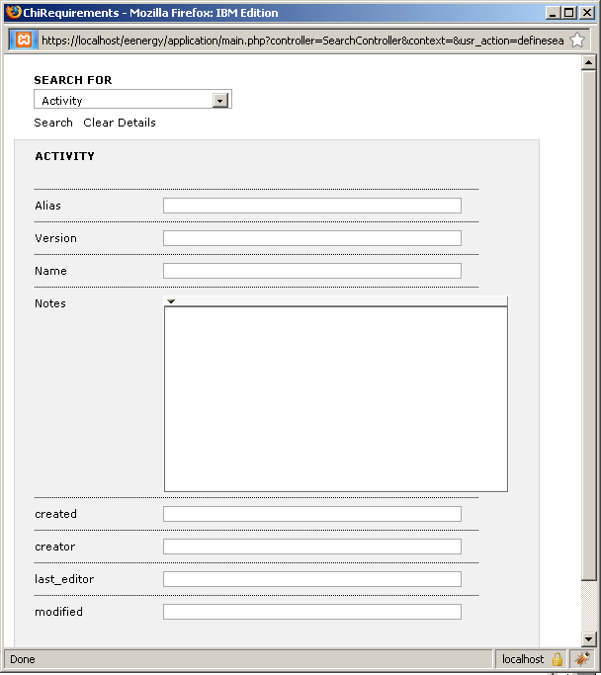

Select one type from the list to get the right search panel depending on special type.

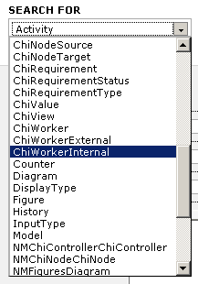
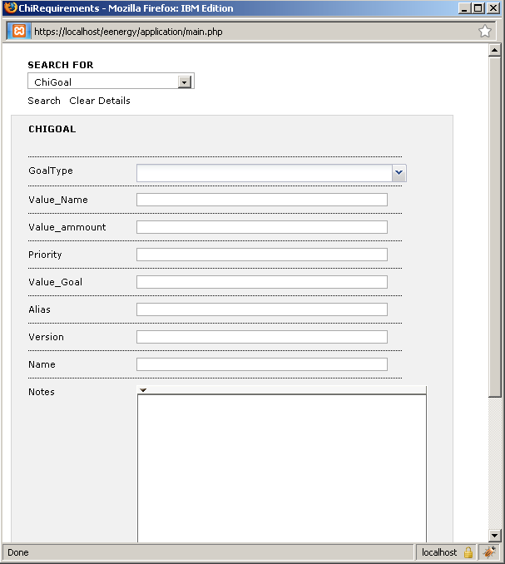
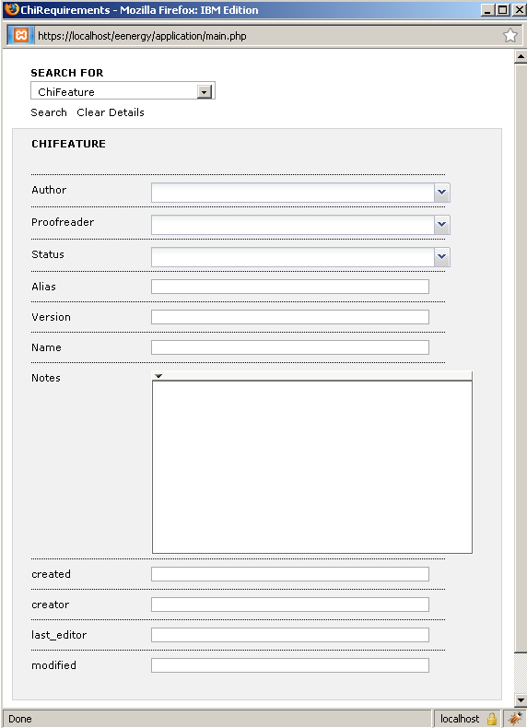

Type in search keys related to each field shown to specify the search. Click link [Search] to start searching on the given criteria.

Results are shown in underlying window like simple search.
Still Open Points

(in Administration area overviewing user, roles and configuration files)
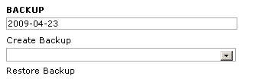

- link [Create Backup]
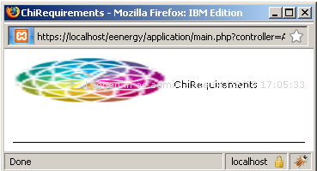
(no message any more and no file found)
.. later on: a second administration window opens

- link [Restore Backup] (no selection possible)

(in normal user area)

- link [Export]
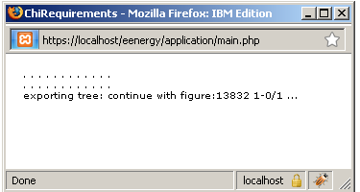
(no message any more but
the export XML file was successfully created in relative path application)

- link [ExportUML] (currently not available)

- link [ImportUML] (currently not available)

- link [Browse Server] (File Upload not working)

